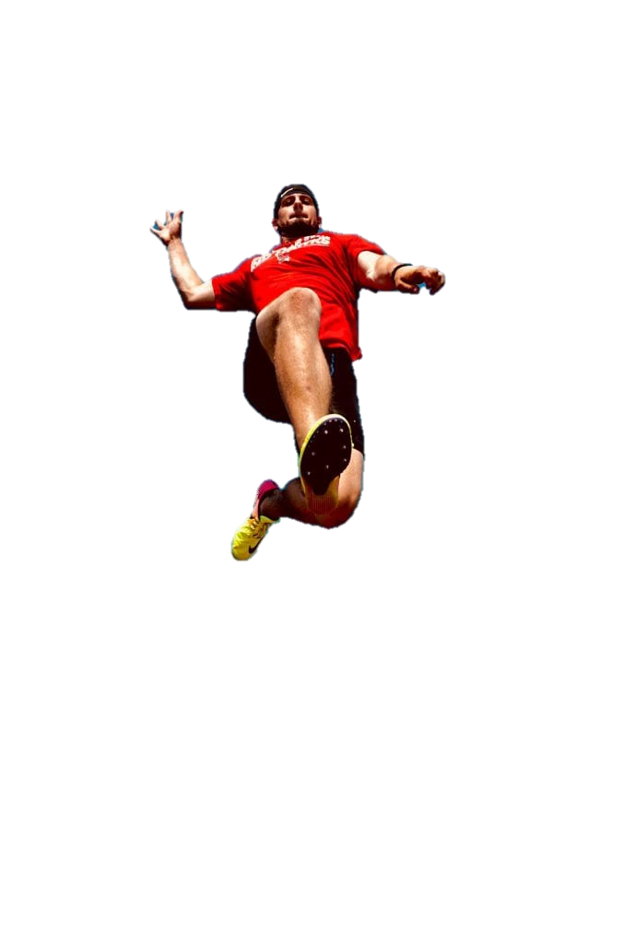

The Priory Witham Academy Physical Education Journey
Believe Together, Achieve Together- inspiring and exciting students to be passionate about learning.
Targeted Swimming
Targeted sessions to support any non-swimmers/ those in need of further support.

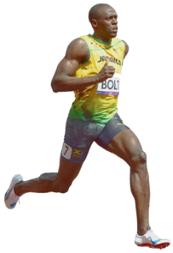
Your Physical Education Journey starts here …
Autumn
Term
Spring
Term
Summer
Term

Swimming
An essential life skill revisited throughout the year and throughout all primary years.

Multi Skills Team
Emphasis is put on cooperative and collaborative work in order to achieve within team based activities.

Multi Skills Movement
Creating different movement patters in order to develop physical literacy and basic skills.

Athletics
Lessons cover the three disciplines of athletics: Throws, Runs and Jumps. Developing the basic technique for each of the events.

Dance
Children skilfully create a series of controlled movement patterns and sequences and tell a story using their body.

Gymnastics
Development of basic sequences and movement patterns. Inclusive of: balances/ movement/ rolls/ jumps and flight.
Sports Day
Students represent their Houses in a variety of events during Sports Day to add towards Whole School scores.
Multi Skills Ball
Skills based lessons with an emphasis on ball skills such as throwing, catching and rolling.

Show Your Commitment
How many can you complete?
Try Your Best in All Lessons
Bring Your PE Kit to All Lessons
Achieve High in All Lessons
Attend Extra-Curricular Clubs Each Term
Represent the Academy in Sporting Events

The School Games
Below are just some of the School Games Events which we enter:
Multi Skills
Invasion
Net /wall
Athletics
Dodgeball
Football
Games

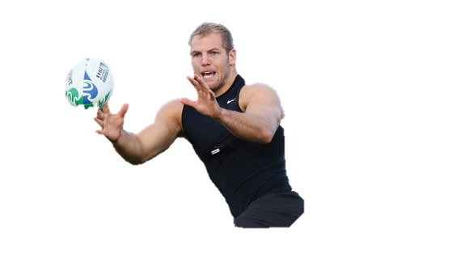

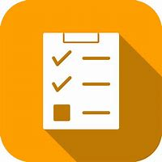

Striking & Fielding
Teamwork focused lessons and emphasis on coordination skills within striking and fielding activities.

Swimming
An essential life skill revisited throughout the year and throughout all primary years.

Invasions Games
Development of strategies and tactics in order to outwit opponents in various invasion games.



School Sporting Values

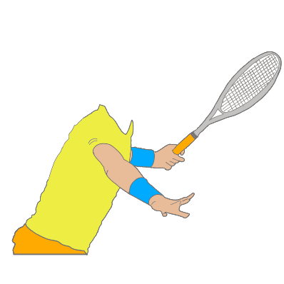
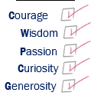

Health & Fitness
Students learn about the body and how to maintain a healthy lifestyle through a variety of fitness based lessons.

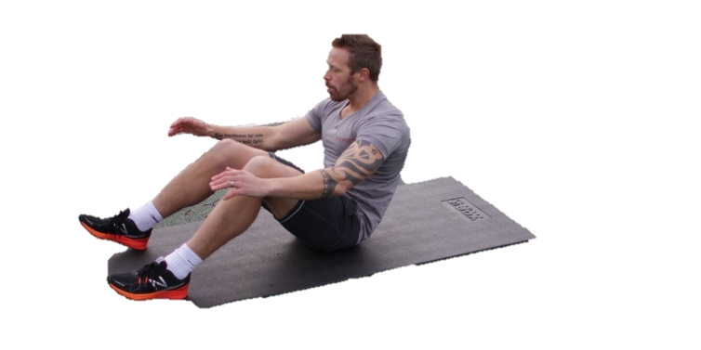
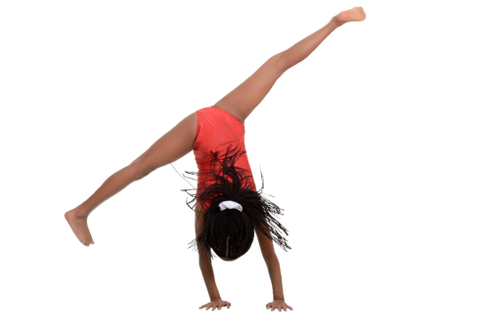

Net/Wall
Development of coordination through various net/wall activities to build on their skills learned throughout multi skills.



