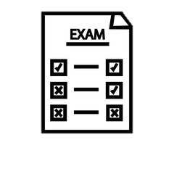
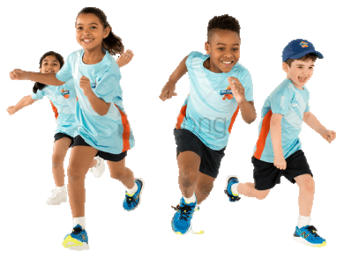

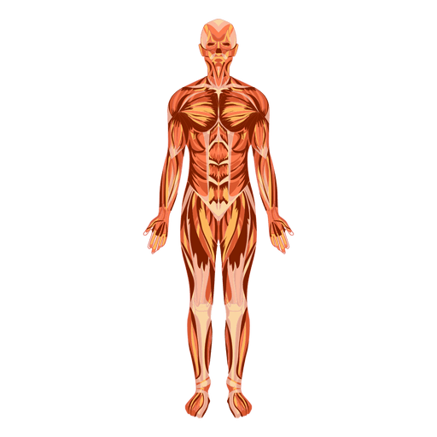

Level 1/2 Tech Award in Sport- Curriculum Map
Your BTEC Physical Education Journey starts here …
Year
10
Year 11

Component 1: Preparing Participants to Take Part in Sport and Physical Activity, Learning Aim A
Learners will explore the different types and provision of sport and physical activities. Learners will understand the different sectors that provide sport and physical activities. They will also understand the advantages and disadvantages of each of these sectors. They will also learn about the different categories and characteristics of participants and how their needs will affect the types of sports and physical activities and providers of each which are best suited to their needs.


Component 3: Developing Fitness to Improve Other Participants Performance in Sport and Physical Activity, Learning Aim B
Learners will understand why fitness testing is carried out and know how to set up and administer the protocol of each fitness test. Learners will also need to be able to use data from fitness tests and compare these to normative data tables to interpret the fitness test results.
Component 3: Developing Fitness to Improve Other Participants Performance in Sport and Physical Activity, Learning Aim A
Learners will understand how each of the components of physical and skill-related fitness are required to perform well in selected sports and how these are used when playing in different positions in team sports.


SCAN HERE to see the Pearson BTEC specification and the content you will cover in more detail.

College/ Apprenticeship
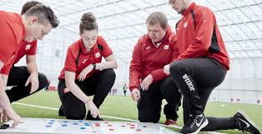
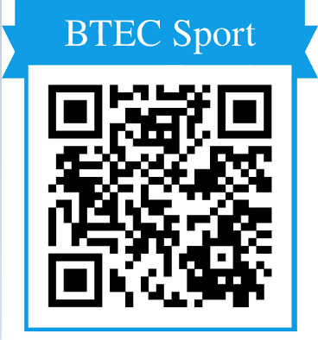
BTEC Level 3 in Sport

Component 3: Developing Fitness to Improve Other Participants Performance in Sport and Physical Activity, Learning Aims C & D
Learners should know how to carry out fitness training safely and effectively as part of a training programme. Learners will also Investigate fitness programming to improve fitness and sports performance.
Component 2: Taking Part and Improving Other Participants Sporting Performance, Learning Aim C
Learners will be able to use methods to improve other participants’ sporting skills. They will be able to provide demonstrations and teaching points to introduce participants to the techniques required for different sporting skills. They will also be able to select and organise suitable drills and support participants to take part in the drills to develop their sporting skills.

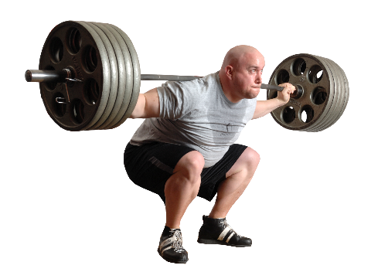
BTEC Physical Education Breakdown

Examination – Component 3
Coursework – Components 1 & 2
Practical – Through the course for each unit

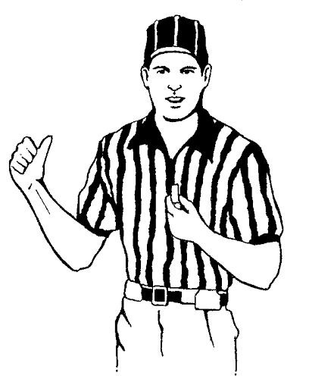

Practical- Throughout the course you will take part in practical lessons to aid with the theoretical side of the course.

Component 1- Learners will explore the different types and provision of sport and physical activity available for different types of participants, barriers to participation and ways to overcome these barriers to increase participation in sport and physical activity. They will also research equipment and technological advances in a chosen sport or physical activity and how to prepare our bodies for participation in sport and physical activity.

Component 2- Learners will investigate the components of fitness and their effect on performance, take part in practical sport, explore the role of officials in sport and learn to apply methods and sporting drills to improve other participants’ sporting performance.

Component 3- Learners will be introduced to and develop an understanding of the importance of fitness and the different types of fitness for performance in sport and physical activity. They will also develop an understanding of the body and fitness testing.

Component 2: Taking Part and Improving Other Participants Sporting Performance, Learning Aim B
Learners will be able to demonstrate the skills and strategies required to be able to participate effectively in isolated practices and competitive situations for a selected sport. Learners will know the different roles of officials for a selected sport and will understand the responsibilities associated with each of these roles. Learners will know the key rules of a selected sport and understand how these may be applied in different situations.
Component 2: Taking Part and Improving Other Participants Sporting Performance, Learning Aim A
Learners will understand each of the components of physical and skill-related fitness. They will be able to apply this understanding to how these components of fitness are used in team sports, individual sports, outdoor activities and physical fitness activities and how they impact on performance.

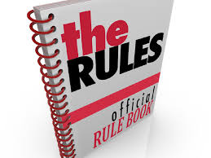


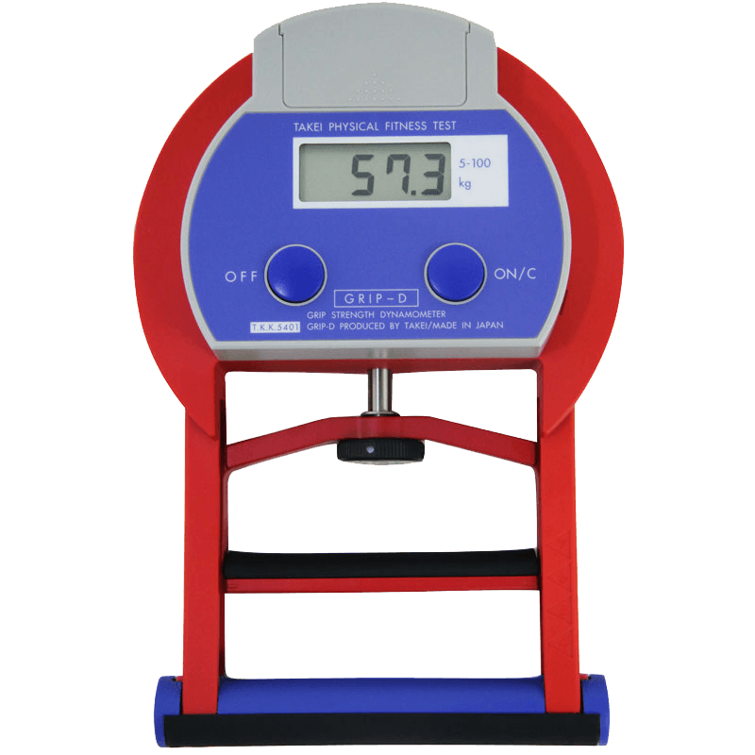
Component 1: Preparing Participants to Take Part in Sport and Physical Activity, Learning Aim C
Learners will learn about the warm-up process that is required to prepare the body to take part in physical activity and the responses of the cardiorespiratory and musculoskeletal systems at each stage of the warm-up. Learners will be able to plan and deliver warm-ups for different physical activities and for different types of participants.
Component 1: Preparing Participants to Take Part in Sport and Physical Activity, Learning Aim B
Learners will need to understand the different types of equipment used to take part in sport and physical activities. They will also explore the different technology available for participation in different sport and physical activities. They will also need to know about the benefits and limitations of technology for sport and physical activity participation.

How will I be assessed?

40% of the course is externally examined- for this you sit an examination at the end of Year 11. The further 60% of the course is assessed internally through coursework and practical tasks.

