
The Priory Witham Academy Health and Social Care Journey

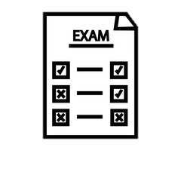
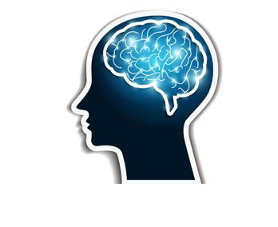
Level 1/2 Tech Award in Health & Social Care- Curriculum Map
Your BTEC Physical Education Journey starts here …
Year
10
Year 11

Component 1: Learning outcome A: Understand human growth and development across life stages and the factors that affect it
Learners will explore different aspects of growth and development across the life stages using the physical, intellectual, emotional and social (PIES) classification.


Component 3: Learning Outcome C: Person-centred approach to improving health and wellbeing
Learners will understand why fitness testing is carried out and know how to set up and administer the protocol of each fitness test. Learners will also need to be able to use data from fitness tests and compare these to normative data tables to interpret the fitness test results.
Component 3: Learning Outcome B: Interpreting health indicators
Learners will explore how physiological indicators are used to measure health.




SCAN HERE to see the Pearson BTEC specification and the content you will cover in more detail.

College/ Apprenticeship
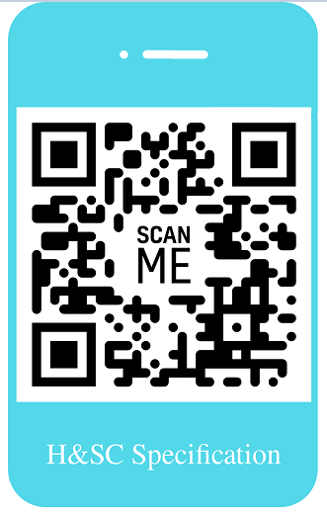
Level 3 in Health & Social Care

Component 3: Learning Outcome A: Factors that affect health and wellbeing
Learners will explore how factors can affect an individual’s health and wellbeing positively or negatively. This links to and extends knowledge and understanding of human lifespan development including life events, covered in Component 1. Here, however, the focus is on the current health and wellbeing of individuals.






BTEC Physical Education Breakdown

Examination – Component 3
Coursework – Components 1 & 2

Component 2: Learning outcome B: Understand the skills, attributes and values required to give care
Learners will explore the skills and attributes that are required when delivering care.

Component 1- Learners will explore different aspects of growth and development and the factors that can affect this across the life stages. They will explore the different events that can impact on individuals’ physical, intellectual, emotional and social (PIES) development and how individuals cope with and are supported through changes caused by life events.

Component 2- Learners will explore health and social care services and how they meet the needs of service users. They will also study the skills, attributes and values required when giving care.

Component 3- Learners will explore the factors that affect health and wellbeing, learning about physiological and lifestyle indicators, and person-centred approaches to make recommendations to improve an individual’s health and wellbeing.






Component 2: Learning outcome A: Understand the different types of health and social care services and barriers to accessing them
Learners will explore a range of healthcare conditions and how they can be managed by the individual and the different healthcare services that are available.
Component 1: Learning outcome B: Understand how individuals deal with life events
Learners will explore life events that occur in an individual’s life. Learners will explore the different events that can impact on people’s PIES development.




How will I be assessed?

40% of the course is externally examined- for this you sit an examination at the end of Year 11. The further 60% of the course is assessed internally through coursework.

